**ORACLE**

academy.oracle.com

Academy

Database Programming with SQL

3-1: Logical Comparisons and Precedence Rules

Practice Activities

Objectives

* Evaluate logical comparisons to restrict the rows returned based on two or more conditions
* Apply the rules of precedence to determine the order in which expressions are evaluated and calculated

Vocabulary

Identify the vocabulary word for each definition below.

|  |  |
| --- | --- |
| NOT | Inverts the value of the condition |
| AND | Both conditions must be true for a record to be selected |
| precedence rules (правила приоритета) | Rules that determine the order in which expressions are evaluated and calculated |
| OR | Either condition can be true for a record to be selected |

Try It / Solve It

1. Execute the two queries below. Why do these nearly identical statements produce two different results? Name the difference and explain why.

SELECT code, description

FROM d_themes

WHERE code >200 AND description IN('Tropical', 'Football', 'Carnival');

SELECT code, description

FROM d_themes

WHERE code >200 OR description IN('Tropical', 'Football', 'Carnival');

Результат:

Ответ:

В первом случае используется AND, поэтому любая из сторон должна вернуть true, но во втором случае - OR, поэтому может появиться больше записей, так как любая из сторон должна быть true для выбора строки.

1. Display the last names of all Global Fast Foods employees who have “e” and “i” in their last names.

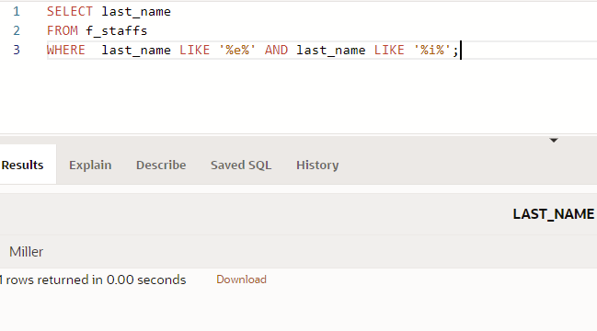

1. I need to know who the Global Fast Foods employees are that make more than $6.50/hour and their position is not order taker.

1. Using the employees table, write a query to display all employees whose last names start with “D” and have “a” and “e” anywhere in their last name.

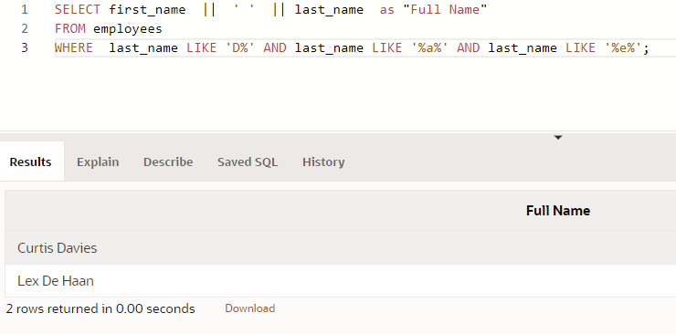

Copyright © 2020, Oracle and/or its affiliates. All rights reserved. Oracle and Java are registered trademarks of Oracle and/or its affiliates. Other names may be trademarks of their respective owners.

1. In which venues did DJs on Demand have events that were not in private homes?

1. Which list of operators is in the correct order from highest precedence to lowest precedence?

a. AND, NOT, OR

b. NOT, OR, AND

c. NOT, AND, OR

For questions 7 and 8, write SQL statements that will produce the desired output.

1. Who am I?

I was hired by Oracle after May 1998 but before June of 1999. My salary is less than $8000 per month, and I have an “en” in my last name.

Листинг:

SELECT first_name || ' ' || last_name as "Full Name"

FROM employees

WHERE hire_date > '1998-05-31' AND hire_date < '1999-06-01' AND salary < 8000 AND last_name like '%en%';

1. What's my email address?

Because I have been working for Oracle since the beginning of 1996, I make more than $9000 per month. Because I make so much money, I don't get a commission.

Листинг:

SELECT LOWER(email) || '@institutedomain.com' as "Email Address"

FROM employees

WHERE salary > 9000 AND (commission_pct = 0 OR commission_pct IS NULL) AND hire_date >= '1996-01-01' AND hire_date <= '1996-05-31';

Copyright © 2020, Oracle and/or its affiliates. All rights reserved. Oracle and Java are registered trademarks of Oracle and/or its affiliates. Other names may be trademarks of their respective owners.